AML 612 Spring 2017 Homework #2

Submit all files to smtowers@asu.edu.
Due Wed Feb 15th , 2017 at noon.

Please submit with name format hwk2_<first name>_<initial of last name> Please provide your R file, and a Word file that gives the output to your R screen, plots, and a latex and bibtex file (with compiled PDF) giving the descriptions of the reviewed papers.

All code must not use tabs, and must conform to good coding practices, as described in http://sherrytowers.com/2012/12/14/good-programming-practices-in-any-language/ and all plots must conform to good plotting practices, as described in http://sherrytowers.com/2013/01/04/good-practices-in-producing-plots/

Question 1

A hypothetical infectious disease has no cure; once you are infected, you do not recover. The disease has an exposed period 1/kappa during which the person has been exposed, but is not yet infectious.

Scientists have developed a treatment for the disease that does not cure the patient, but at least makes them shed less pathogen such that they are less likely to transmit the infection to others. This produces a “discount on infection”, sigma with 0<=sigma<=1 (where sigma=1 means the treatment is ineffective). The patients flow into the treated class with rate tau.

We include vital dynamics in the model, such that the birth rate and death rate are both equal to mu.

The model equations are as follows:

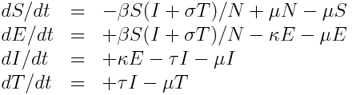eqn1

- Show that, at the endemic equilibrium,
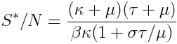 eqn 2

- Using the result in A, find the expression for the maximum value of beta such that the disease will still die out in the population in the absence of treatment (ie; without treatment means tau=0). This is what we will refer to below as the “threshold value of beta”

- Write R code that solves the set of differential equations given above. Assume that 1/mu=70 years, 1/kappa=0.5 years, sigma=1 and tau=0 (ie; no one is being treated). Start with a population of N=1,000,000, and E=0, I=1, T=0, and S=N-E-I-T, and solve the system of equations over a 5000 year time period. Do the following, overlaying the plots of the logarithm of the prevalence on top of one and other:

Set beta equal to the threshold value, calculated above
Set beta equal to 0.5 times the threshold value
Set beta equal to 1.1 times the threshold value
Set beta equal to 1.5 times the threshold value
Set beta equal to 3 times the threshold value

Produce the following plot (using different colours than the ones I used here) with properly labelled axes, legend, and plot title:

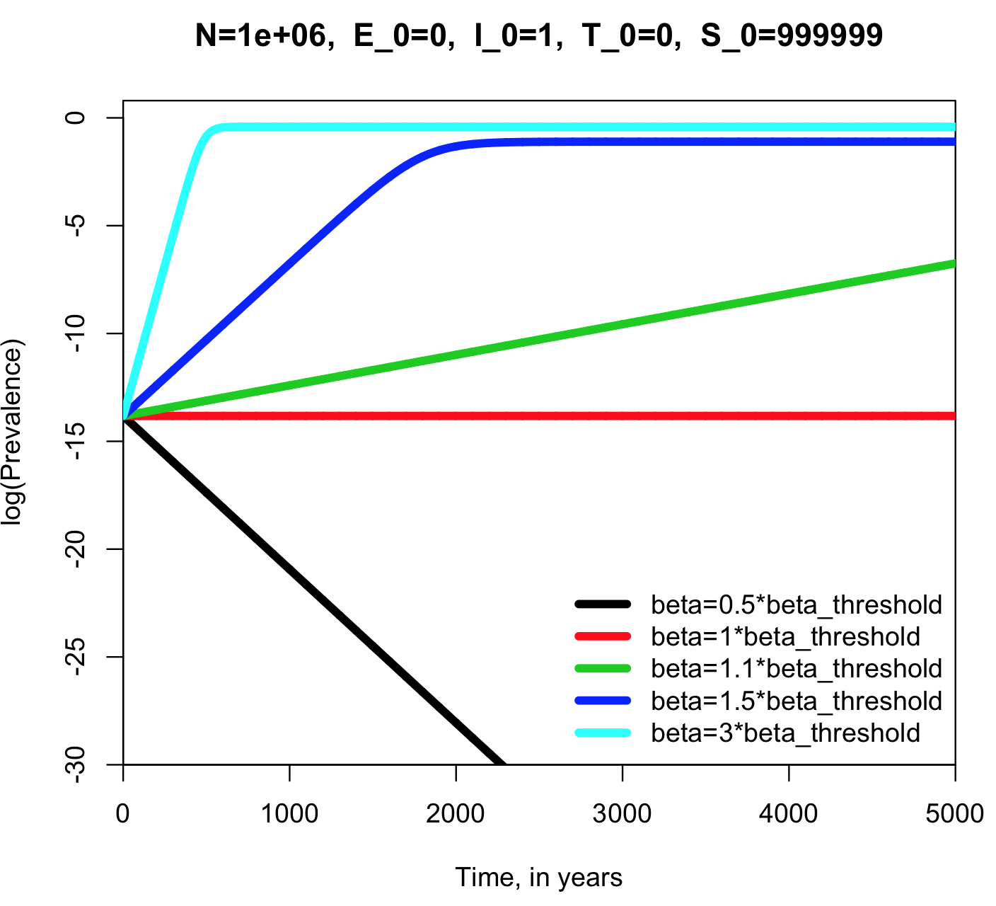

- For each value of beta, what was the expected equilibrium value of S*/N, and what was the observed value at the end of the 5000 years?
- Now, keeping beta=3*beta_threshold, make the following plot overlaying the log of the prevalence for the following hypotheses (make the colours in your plot different than the ones I used here)
  - tau=0, sigma=1
  - tau=0, sigma=0.5
  - tau=1/3, sigma=1
  - tau=1/3, sigma=0.5
  - tau = 1/1.5, sigma=0.5
  - tau=1/3, sigma=0.25
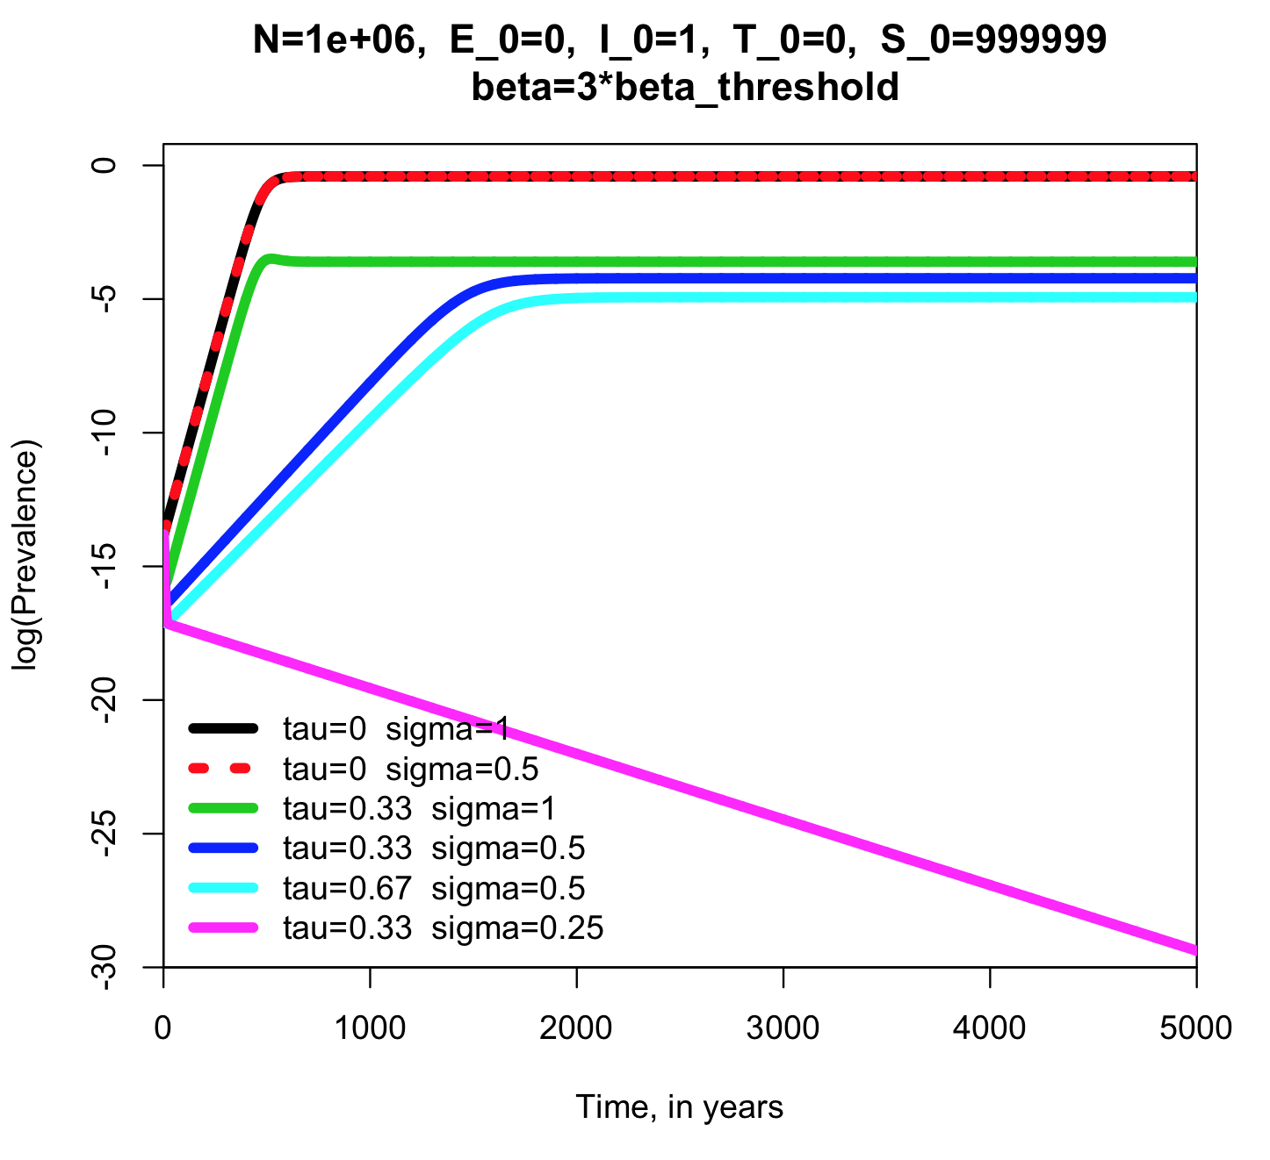
- Based on the plot results, compared to tau=1/3 and sigma=0.5, which is the better strategy to reduce the burden of disease in the population; doubling the rate at which people are treated, or making the treatment twice as efficacious?

Question 2

Read the paper:

Del Vicario, Michela, Alessandro Bessi, Fabiana Zollo, Fabio Petroni, Antonio Scala, Guido Caldarelli, H. Eugene Stanley, and Walter Quattrociocchi. "The spreading of misinformation online." Proceedings of the National Academy of Sciences 113, no. 3 (2016): 554-559.
http://www.pnas.org/content/113/3/554.full

- Create a latex document that gives the title of the paper, and provides a short description of the study presented. Read the module Elements of Scientific Papers at http://sherrytowers.com/?p=3409 Using the rubric of Lacum et al, identify and discuss the seven key elements. If one or more of the elements appears to be missing in the paper, comment on it. Comment on the importance of the paper and the uniqueness of the analyses. Cite the paper in your latex document using bibtex, and compile the file to produce a PDF document (make sure all of the references are resolved when you compile the latex document! i.e. no [?] citations).

- Using DataThief, download the data from Figure 1 in the paper. Write the R code to qualitatively reproduce the figure, using a different colour scheme (it is OK to have the legend in the plot area, rather than beside it, but make sure all axes are properly labelled). In your homework submission, put the original figure and your re-creation side-by-side for comparison:

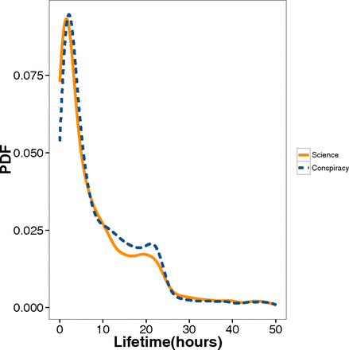
Question 3

- Using Google Scholar, search for a paper on a research topic that interests you. The paper must involve a compartmental mathematical model, and must also involve a comparison of the model to data. It must be a different paper from those reviewed in Homework #1.

- Open a bibtex and create an annotated bibliography that contains the bibtex entry for the paper. Add a latex comment the entry, add the abstract, and also a short summary in your own words of the article.

- In the latex document formed in question 2, additionally add the title of this paper, and provide a short description of the study presented in the paper. Using the rubric of Lacum et al, identify and discuss the seven key elements. If one or more of the elements appears to be missing in the paper, comment on it. Comment on the importance of the paper and the uniqueness of the analysis. Cite the paper in your latex document using bibtex, and compile the file to produce a PDF document (make sure all of the references are resolved when you compile the latex document! i.e. no [?] citations).

Submit the pdf of the paper, your bibtex file, the latex file, and the compiled PDF of the latex file.

