AML 610 Fall 2014 Homework #4

Submit all files to smtowers@asu.edu.
Due Wed Sep 24th , 2014 at noon.

Please submit with name format hwk4_<first name>_<initial of last name> Please provide your R file, and a Word file that gives the output to your R screen, plots, etc.

All code must conform to good coding practices, as described in http://sherrytowers.com/2012/12/14/good-programming-practices-in-any-language/ and all plots must conform to good plotting practices, as described in http://sherrytowers.com/2013/01/04/good-practices-in-producing-plots/

Question 1

Go to the Wikipedia page that discusses various types of basic compartmental epidemic models: http://en.wikipedia.org/wiki/Epidemic_model
Now read about the epidemiology of Ebola, as described on these two pages: https://microbewiki.kenyon.edu/index.php/Infection_Mechanism_of_Genus_Ebolavirus and http://en.wikipedia.org/wiki/Ebola_virus_disease
Based on what you have learned about the epidemiology and transmission of the disease, suggest a compartmental model that would be appropriate for modeling an Ebola outbreak. (btw, there is no one right answer here… there are, however, some compartments that should be in every Ebola compartmental model).
Do you think that you need to include births and/or deaths in the model? If so, why? If not, why do you think one or more should be neglected? Write down the equations for your model (you can do this in latex and submit the PDF). What are the parameters? Which are known, and which are unknown?

Question 2

It is important to understand how changing the parameters of your model changes your model predictions. In this question, you will examine an SEIR model.

a) Assume an SEIR model is appropriate for a particular disease. Write down the differential equations for the model, with the assumption that the parameter names are beta (transmission rate), kappa (rate of flow from E to I), gamma (rate of flow from I to R). Ignore births and deaths. Assume standard incidence, not mass action incidence. Give an example of a disease for which such an SEIR model might be appropriate.

b) What is the reproduction number for this model, as a function of the transmission rate, beta? (ie; look it up if you don’t know yet how to derive it)

c) Derive the expression for the value of S when I is at its maximum. Is this related to the reproduction number?

d) Write the R code to solve the equations of an SEIR model using the methods deSolve library. Assume that the values of the incubation and infectious periods for that disease are known to be 1/kappa = 10 days, 1/gamma = 10 days.

e) Plot the model estimates for the prevalence fraction I/N vs time for 500 days, in steps of 1 day, for the model solved under the following conditions:
N = 10,000 (population size)
I_0 = 1
E_0 = 0
S_0 = Npop-1
R_0 = 0 (initial number recovered, not the reproduction number).
R0 = 2.0 (the reproduction number)
t0 = day 0 (day that the infection introduced into the population)

You should get a plot that looks like the one below. Hint: to overlay text on your figure, it helps to first overlay a blank plot with x and y axes going from 0 to 1. Then you have a well-defined coordinate system over which to put text, and it will not depend on whether or not the x and y axes of the original plot change. For example:
plot(time,I/N) # original plot
par(new=T)
plot(c(0,1),c(0,1),col=0,axes=F,xaxt="ni",yaxt="ni",xlab="",ylab="") # overlay blank
text(0.70,0.90,paste("N=",N,sep=""),adj=c(0,1))
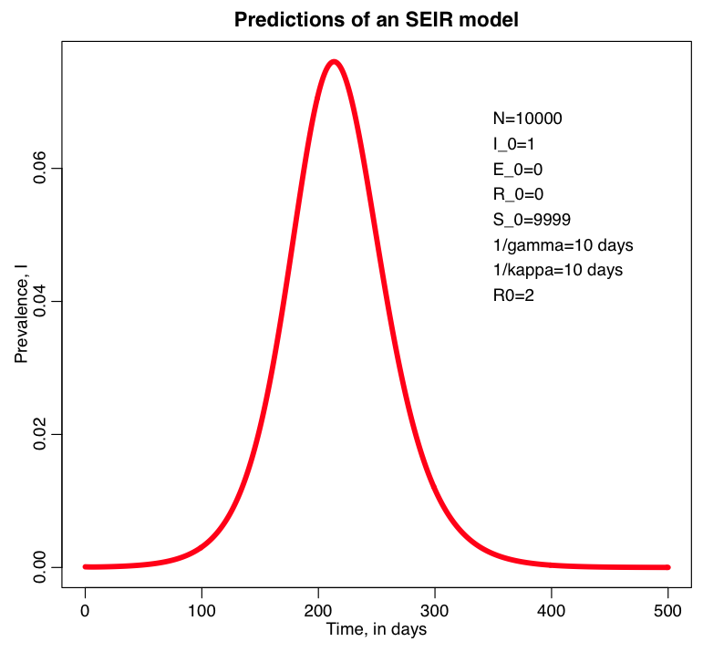

f) What fraction of people got sick by the end? Hint: subtract S on the last day from S on the first day, and divide by N. Or, alternatively, look at R on the last day minus R on the first day. Write the code to print the fraction of the population that got ill by the end. Why are predictions for the final size of the epidemic important for public health officials to know?

g) Write the R code to print the day that I/N is maximal. On what day is I/N maximal? What is the maximum value of I/N? Why are estimates of the maximum value of I/N, and the day on which I/N is maximal, important information for public health officials to know?

h) Repeat f) and g) with N=100,000. Did the numbers change? How does making the population size go up affect things?

i) go back to the original model parameters, but change 1/kappa=5 days. Repeat f) and g). Did the numbers change? How does making the incubation period shorter appear to affect things?

j) go back to the original model parameters, but change 1/gamma=5 days. Repeat f) and g). Did the numbers change? How does making the infectious period shorter appear to affect things? Antiviral treatment for diseases like flu can make the infectious period shorter. Comment on the public health implications for what this does to the epidemic curve.

k) go back to the original model parameters, but change R0=1.8. Repeat f) and g). Did the numbers change? How does making the reproduction number smaller appear to affect things? Social distancing during an epidemic can reduce R0. Comment on the public health implications for what this does to the epidemic curve.

l) go back to the original model parameters, but now use the following initial conditions I_0=1, E_0=0, R_0=0.2*N, S_0=N-I_0-E_0-R_0. Repeat f) and g). Did the numbers change? These changes are equivalent to doing what to the reproduction number: raising, or lowering? Vaccination increases the fraction of the population that is “recovered” and immune at the beginning of an epidemic. Comment on the public health implications for what this does to the epidemic curve.

m) go back to the original model parameters, but now use the following initial conditions I_0=1, E_0=0, R_0=0.5*N, S_0=N-I_0-E_0-R_0. Repeat f) and g). Comment on the results, and the reason behind what you observe. Measles has a basic R0 of around 11 to 18: http://www.eurosurveillance.org/ViewArticle.aspx?ArticleId=20233
Take a look at the US vaccination rates for kids listed on this page: http://www.cdc.gov/nchs/fastats/immunize.htm
Measles outbreaks in the US are rare. Why?

n) go back to the original model parameters, but now use the following initial conditions I_0=10, E_0=0, R_0=0, S_0=N-I_0-E_0-R_0. Repeat f) and g). Does the final size change much? How about the maximum prevalence? What does change, and why?

Question 3

Using Google Scholar, find a paper on a topic that interests you that involves compartmental models (not any of the papers you submitted for previous homeworks). Read the web post “How to write a good scientific paper (and get your work published as painlessly as possible)” which can be found at http://sherrytowers.com/?p=1876 In the post, I describe the seven key elements of scientific papers, identified by Lacum et al (2014). Read the Lacum paper (it is linked off of the web page). For your paper, provide in a latex document, with the paper cited, an itemized list of short sentences summarizing each of the 7 key elements. If the paper does not discuss one or more of the key elements, point that out. Please also provide the PDF of the paper. Pay close attention to the difference between Motive and Objective.

