AML 610 Fall 2014 Homework #9

Submit all files to smtowers@asu.edu.
Due Wed Nov 19th , 2014 at noon.

Please submit with name format hwk9_<first name>_<initial of last name> Please provide your R and C++ files, and a Word file that gives the output to your screen, plots, etc.

All code must conform to good coding practices, as described in http://sherrytowers.com/2012/12/14/good-programming-practices-in-any-language/ and all plots must conform to good plotting practices, as described in http://sherrytowers.com/2013/01/04/good-practices-in-producing-plots/

Question 1

a) Together with your project group, make a plot of your time series of data sources, suitable for inclusion in your final paper. Include the plot(s) in the paper with appropriate captions, and wording in the text referring to the figure(s). Make sure your axes are appropriately labeled, with an appropriate legend on the plot, attractive colors and line widths, etc.

b) Write the R code to solve the differential equations associated with your model.
For a set of parameters that you deem to be “reasonable” make the plot of model prediction for the quantity that you observe in your data samples, appropriately binned in the same time units as your data. Label the plot appropriately, and include it in the paper with an appropriate caption, and wording in the text referring to the figure. This figure is going to be a placeholder in your manuscript for the final figure which will show your best-fit model overlaid on the data

c) Modify the ModelEquations class in the cpp_deSolve class to solve the system of equations associated with your model.
For the same parameters you used in b), write a program to solve the model, and output the model estimates to a file.

Similar to what you did in homework #8, make plots that overlay the results of the model estimates from your R and C++ programs, including the plot of the relative residuals. Make sure that the results from the C++ and R programs agree to within one part in 10,000.

d) add to the Methods section of your paper a description of the random uniform sampling methodology used to optimize your model parameters to data. For those of you using count data, which I believe is all of you, you will be using the Pearson chi-squared statistic corrected for over-dispersion via the ansatz of McCullagh and Nelder (1989) as your goodness of fit statistic. State explicitly that the iterations were performed with the use of NSF XSEDE resources (you will be required in a later homework to actually use the XSEDE system to do your parameter sweeps). Add an Acknowledgements section to your manuscript, and, as I did in the Ebola/Twitter/Google paper, add an acknowledgement to the NSF for our education allocation on XSEDE.

Question 2

a) In the module http://sherrytowers.com/2014/11/02/submitting-jobs-to-the-asu-a2c2-asure-batch-computing-system/
we discussed how to use the ASU A2C2 ASURE batch computing system to run a program called Flue_example.cpp to perform parameter sweeps of the parameters of an SIR model, and compare the results to confirmed influenza B case count data from the 2007-08 Midwest influenza season.

As described on that web-page, link and compile the Flu_example.cpp program on that web-page. Submit 5 jobs to run the program in batch on the ASURE cluster. Immediately after submitting, type
squeue –u <your username>
and take a screen shot of the queue showing your five jobs running. Copy and paste the screen shot into your homework Word file.

b) Concatenate the output of your 5 jobs together and copy it over to your local machine. Using this output file, make the plot similar to the one seen at the bottom of http://sherrytowers.com/2014/11/02/submitting-jobs-to-the-asu-a2c2-asure-batch-computing-system
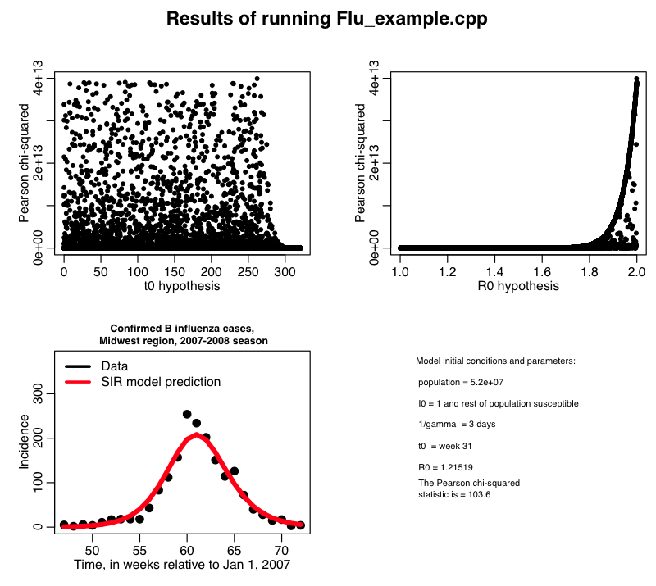

c) repeat step a), this time running on the XSEDE Stampede cluster instead of the ASU A2C2 ASURE cluster. Copy and paste the screen shot showing your five jobs running in the queue to your Word file.

d) concatenate the results of step c) together, and copy to your local machine, and make the plot.

